

Submitted By: ACNABIN, Chartered Accountants

Technical Proposal for Consultancy Services and Advanced Excel-Based Expected Credit Loss (ECL) Solution under IFRS 9

Uttara Bank PLC.

Contents
Transmittal Letter 1
1 Executive Summary 3
1.1 Introduction 3
1.2 Understanding of the Assignment 3
1.3 Objectives of the Engagement 4
1.4 Scope 4
1.5 Firm’s ability to perform the assignment 6
2 Professional Experience 7
2.1 Why ACNABIN is different? 7
2.2 ACNABIN’s overall size, structure and qualification 7
2.3 Similar Assignments 8
3 Methodology of the Assignment 9
3.1 Proposed Methodology at a Glance 9
3.2 IFRS 9 Framework Development 9
3.3 Development of Risk Parameters 10
3.4 Advanced Excel Based ECL Solution 12
3.5 Model Validation and Implementation Support 12
3.6 Regulatory Reporting and IFRS 9 Disclosures 12
3.7 Knowledge Transfer and Sustainability 13
4 Proposed Deliverables 14
5 Our Assumptions 15
6 Service Level Agreement (SLA) and Post-Implementation Support 16
7 Confidentiality & Conflict of Interest Declaration 18
8 The Proposed Project Team Composition 19
9 Proposed Timeline 20

List of Annexures

- Annexure A: Organizational Profile
- Annexure B: Certificate of Experience
- Annexure C: CV of Team Members
- Annexure D: Legal Documents

Transmittal Letter

01.18/2026/

Mr. Md. Rafiqul Islam Khan
General Manager
Purchase & Procurement Department
Uttara Bank PLC.
Head Office (12th Floor)
47, Shahid Bir Uttam Asfaqus Samad Sarak
Motijheel, Dhaka-1000

13 July 2026

Submission of Technical Proposal for Providing Consultancy Services together with Advanced Excel-Based Expected Credit Loss (ECL) Solution under IFRS 9

Dear Sir,

With reference to your Request for Proposal for providing consultancy services together with Advanced Excel-Based Expected Credit Loss (ECL) Solution under IFRS 9 of Uttara Bank PLC., we are pleased to submit herewith our technical proposal for your kind consideration. We have submitted our financial proposal in a separate envelope.

ACNABIN, Chartered Accountants is submitting this proposal as the Lead Consultant, in association with CipherShield Bangladesh and IFRS 9 Specialists from SolveOrbit. This proposed team has been carefully structured to provide Uttara Bank PLC with an integrated and practical implementation solution covering accounting, risk modelling, data, technology, automation, reporting, and knowledge transfer.

In addition to providing consultancy services, our consortium will deliver a fully functional Advanced Excel-based ECL solution incorporating portfolio-level and loan-level Expected Credit Loss calculations, PD, LGD and EAD methodologies, forward-looking macroeconomic scenarios, management overlays, comprehensive reporting, audit trails and documentation in accordance with Bangladesh Bank's IFRS 9 Roadmap and Guidance.

Our proposed consortium brings together the following complementary strengths:

ACNABIN, Chartered Accountants, as Lead Consultant, will provide project leadership, regulatory and financial reporting guidance, Bangladesh banking sector understanding, IFRS advisory support, stakeholder coordination, documentation review, training, and overall quality assurance.

CipherShield Bangladesh will bring strong technology, data, system integration, automation, IT control, reporting, and implementation support capability, particularly relevant for operationalizing the IFRS 9 ECL framework within the Bank’s systems and reporting environment.

IFRS 9 Specialists from SolveOrbit will contribute international IFRS 9 implementation experience, including practical exposure to ECL framework development, PD/LGD/EAD modelling, significant increase in credit risk methodology, staging criteria, model validation, parallel run, and post-implementation support for banks and financial institutions.

Through this combination, we believe the proposed team is well positioned to deliver a complete IFRS 9 implementation solution for Uttara Bank PLC from policy to model, model to system, system to automation, and automation to reporting.

We are confident that our combined professional experience, Bangladesh banking regulatory knowledge, international IFRS 9 implementation exposure, technology implementation capability, and commitment to knowledge transfer will enable us to complete the assignment efficiently and to the full satisfaction of Uttara Bank PLC.

We sincerely thank Uttara Bank PLC for giving us the opportunity to submit this proposal. We would be pleased to present our proposed approach before the evaluation committee and provide any further information or clarification that may be required.

Thank you.

Yours faithfully,

Muhammad Aminul Hoque FCA
Partner
amin@acnabin-bd.com

Executive Summary

Introduction

The implementation of IFRS 9 Financial Instruments is a significant regulatory, accounting, credit risk and systems transformation for banks in Bangladesh. It requires a shift from a largely rule-based provisioning framework to a forward-looking Expected Credit Loss model that considers historical experience, current conditions, credit risk behavior and reasonable forward-looking information. This transition will affect financial reporting, loan classification, impairment recognition, credit risk governance, data management, model governance, system architecture, internal controls and regulatory reporting.

Bangladesh Bank has set a clear and binding direction. The roadmap issued through BRPD Circular Letter No. 03 of 23 January 2025, reinforced by the implementation guideline of March 2026, requires all scheduled banks to adopt the ECL approach in phases. From 1 January 2028, ECL applies to loans, advances and off-balance-sheet exposures; from 1 January 2029, the framework extends to all financial instruments. Throughout the transition, banks are expected to hold provisions at the higher of existing regulatory requirements or the IFRS 9 ECL outcome.
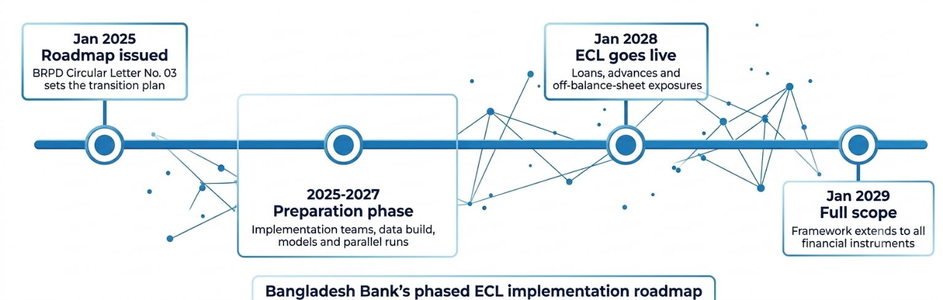

Unlike a conventional advisory engagement, the assignment requires the Consultant to provide an implementation-ready Advanced Excel-based ECL solution together with the complete IFRS 9 implementation framework. Accordingly, our approach integrates regulatory advisory, model development, spreadsheet-based automation, validation, reporting, documentation, training, and post-implementation support into a single implementation programme. The proposed solution has been designed to remain transparent, auditable, fully customizable and capable of accommodating future regulatory updates issued by Bangladesh Bank.

ACNABIN’s proposed approach focuses on practical implementation, regulatory alignment and institutional capacity building. We will assist Uttara Bank PLC. in developing a framework that is compliant with IFRS 9 and Bangladesh Bank Guidance, but also understandable, explainable and maintainable by the Bank’s own team. Our objective is to deliver a solution that is not dependent on a black-box model, but is supported by clear methodology, documented assumptions, data lineage, management judgment, control points and reporting discipline.

Understanding of the Assignment

Based on our review of the RFP, we understand that Uttara Bank PLC. requires an end-to-end implementation partner to support the development, implementation and operationalization of an IFRS 9-compliant Expected Credit Loss (ECL) framework together with an Advanced Excel-based ECL solution. The engagement covers the complete implementation lifecycle including framework development, governance, data assessment, methodology development, spreadsheet-based model development, validation, pilot implementation, parallel run, regulatory reporting, disclosures, training and post-implementation advisory support extending through the Bangladesh Bank implementation roadmap.

Objectives of the Engagement
The primary objective of this engagement is to support Uttara Bank PLC. in developing and implementing a robust, transparent, and sustainable IFRS 9 Expected Credit Loss (ECL) framework together with an Advanced Excel-based ECL solution that complies with the requirements of IFRS 9, Bangladesh Bank's implementation roadmap, and international best practices.
The specific objectives of the engagement are to:
- Develop a comprehensive IFRS 9 impairment framework covering governance, accounting policies, portfolio segmentation, staging criteria, Significant Increase in Credit Risk (SICR), default definition, and impairment methodology.
- Assess the Bank's data availability and quality, identify data gaps, and recommend practical remediation strategies, including the application of reasonable and supportable proxy methodologies where necessary.
- Develop statistically sound methodologies for Probability of Default (PD), Loss Given Default (LGD), Exposure at Default (EAD), and forward-looking macroeconomic adjustments appropriate to the Bank's portfolio characteristics.
- Design and deliver an Advanced Excel-based ECL solution capable of performing loan-level and portfolio-level Expected Credit Loss calculations in a transparent, auditable, and user-friendly environment.
- Validate the developed ECL framework and spreadsheet solution through reasonableness testing, sensitivity analysis, reconciliation, parallel run, and User Acceptance Testing (UAT).
- Develop comprehensive technical documentation, methodology papers, user manuals, governance documents, validation reports, and operational procedures to support regulatory compliance, independent review, and future enhancement.
- Support the Bank in preparing IFRS 9 impairment disclosures, management reports, and regulatory reporting requirements arising from the implementation of the Expected Credit Loss framework.
- Conduct knowledge transfer programmes and hands-on training to enable the Bank's Finance, Risk Management, Credit, Internal Audit, and IT teams to independently operate, maintain, and further enhance the ECL framework.
- Provide implementation advisory and post-deployment support to facilitate a smooth transition to the Bank's operational environment and ensure the long-term sustainability of the developed solution.

Scope

Our proposed scope of work has been designed to provide Uttara Bank PLC. with an end-to-end implementation of an IFRS 9 compliant Expected Credit Loss (ECL) framework together with an Advanced Excel-based ECL solution. The engagement encompasses the complete implementation lifecycle, from framework development and data assessment through model development, validation, implementation support, and knowledge transfer.

The proposed scope of work comprises the following key workstreams:

Sl. No. | Workstream | Key Activities | Expected Deliverables
1 | Project Initiation & Governance | Establish project governance structure, conduct kick-off meetings, confirm implementation roadmap, stakeholder responsibilities, communication protocols, and project planning. | Project Charter, Implementation Plan, Governance Framework.
2 | Data Assessment & Preparation | Review data availability, assess data quality, identify gaps, develop data templates, recommend remediation measures, and define data governance requirements. | Data Assessment Report, Data Gap Analysis, Data Requirements Document.
3 | IFRS 9 ECL Framework Development | Develop portfolio segmentation methodology, staging criteria, SICR assessment, default definition, accounting policies, governance framework, and impairment methodology aligned with IFRS 9 and Bangladesh Bank requirements. | IFRS 9 ECL Framework Document and Governance Manual.
4 | Risk Parameter Development | Develop methodologies for PD, LGD, EAD, forward-looking macroeconomic adjustments, management overlays, and scenario weighting using available historical information and appropriate benchmarks. | PD, LGD, EAD Methodology Documents and Calculation Frameworks.
5 | Advanced Excel-Based ECL Solution | Design and develop an automated spreadsheet-based ECL solution incorporating data validation, calculation engines, dashboards, reporting templates, scenario analysis, and audit trails. | Advanced Excel-Based ECL Model with User Documentation.
6 | Validation & Parallel Run | Perform model validation, reasonableness testing, sensitivity analysis, reconciliation, parallel run, User Acceptance Testing (UAT), and issue resolution. | Validation Report, Parallel Run Results, UAT Sign-off.
7 | Reporting & IFRS 9 Disclosures | Develop management reports, regulatory reporting templates, financial statement disclosure support, reconciliation reports, and audit documentation. | Regulatory Reports, Management Reports, IFRS 9 Disclosure Templates.
8 | Knowledge Transfer & Capacity Building | Conduct workshops, technical training sessions, operational guidance, and hands-on knowledge transfer for relevant Bank personnel. | Training Materials, User Manuals, Knowledge Transfer Completion Report.
9 | Post-Implementation Support | Provide implementation advisory, technical clarification, issue resolution, and support during the initial operational period following deployment of the ECL framework. | Post-Implementation Support and Advisory Services.
This integrated approach ensures that Uttara Bank PLC. receives not only an IFRS 9 compliant Expected Credit Loss methodology but also a practical, transparent, and sustainable solution that can be independently operated, maintained, and enhanced by the Bank while remaining aligned with evolving regulatory requirements and industry best practices.

Firm’s ability to perform the assignment

ACNABIN was formed in February 1985, with a mission to continually add value by helping clients succeed. The firm has been in public practice for more than 41 years. The then-largest partnership firm was founded to build an institution fostering an environment for leadership, continuous growth, learning, and collaboration. Over the years, the firm has become one of Bangladesh's leading and most reputable chartered accountancy firms with global affiliations. Regarding the number of partners and manpower resources, ACNABIN is currently the largest accounting firm in Bangladesh. ACNABIN has eight partners whose expertise in audit, accounting, review, business consulting, business process outsourcing, technology solutions and taxation has established the firm as a multidisciplinary organisation. All the partners have many years of experience working at home and abroad and with international consultants and organisations operating locally and globally. ACNABIN is regarded as one of the top firms of chartered accountants in the country’s context and has significant exposure in the relevant market. Since the firm's inception, ACNABIN has been providing auditing, management consultancy, accounting solutions, various reviews and tax consultancy services to clients (now numbering over 450) actively involved in industry, trade, finance, micro finance, education, health, social services, and agriculture in the public and private sectors throughout Bangladesh. Please see Annexure A for our organizational profile.
The global affiliations of ACNABIN have enabled the firm and its people to obtain training overseas and up-to-date information and knowledge in the profession. ACNABIN was associated with Arthur Andersen, LLP the then global leader in the profession from 1992 till the closure of the accounting conglomerate in 2002. Prior to the association, ACNABIN represented BDO, the fifth largest accounting firm in the world serving for more than hundred years. Currently, ACNABIN is an independent member firm of Baker Tilly International, an international accounting network of 41,000 professionals 145 countries.

Till 1992 | 1992-2002 | 2004-Till Date
 |  | 

Professional Experience

Why ACNABIN is different?

ACNABIN’s philosophy:

ACNABIN’s Vision:
We go beyond the traditional auditor and client relationship by becoming your Trusted Business Advisor.

ACNABIN’s Mission:
We adhere to the strictest principles of client confidentiality. The sensitive and competitive nature of proprietary information-and the maintenance of trust-demands it. We have built our success on such principles. We do our utmost to earn and keep-client trust.
Strategic Intent:
We want to become a trusted leader in the market ensuring the highest level of professional ethics and competencies. While securing a safe & trusted position in the market for Govt. Organizations, Banks/NBFIs, telecommunications, foreign branch & liaison offices and NGOs/NPOs, we still see wider space for us to get involved in other sectors in the country and in the region.

“Our culture is driven by the Baker Tilly Internal core values:
- To lead by example
- To deliver quality services with integrity
- To communicate openly, to act ethically
- And to foster a community built around civic responsibilities and teamwork.

ACNABIN’s overall size, structure and qualification

Presently, infrastructure and manpower wise ACNABIN is considered to be the largest chartered accountancy firm in Bangladesh, with the highest number of partners and the highest number of staff members including articled students. The manpower strength of ACNABIN, chartered accountants is provided below:

Sl. # | Personnel | Number
01. | Partners | 08
02. | Professional Staff:
 | - Qualified (CA, CMA & ACCA) | 25
 | - Part Qualified/ CA Course Completed (CC) | 94
 | - Other Professional Staff | 59
 | - ACCA /CMA Staff | 5
 | - Lawyers | 1
 |  | 184
03. | Articled Students:
 | - Registered | 295
 | - Probationary | 78
 |  | 373
04. | ACCA Students/Trainee | 02
05. | Supporting Staff | 26
 | Total | 493

All the partners are Chartered Accountants and Fellow members of the Institute of Chartered Accountants of Bangladesh, one of whom is also an Associate member of ICAEW and a Fellow member of ACCA, UK. The firm operates from Dhaka, with a Head Office space of 13,772 ft. and a branch Office space of 2,154 ft.

Annexure A provides a detailed Organizational profile of ACNABIN. You are also welcome to visit our website: http://www.acnabin.com.

Similar Assignments

SL | Name of Client | Type | Experience of
1 | National Bank of Pakistan | IFRS Implementation | SolveOrbit
2 | House Building Finance Company Limited | IFRS Implementation | SolveOrbit
3 | JS Bank Limited | IFRS Implementation | SolveOrbit
4 | Silk Bank Limited | IFRS Implementation | SolveOrbit
5 | United Bank Limited | IFRS Implementation | SolveOrbit
6 | First Woman Bank Limited | IFRS Implementation | SolveOrbit
7 | Sindh Bank Limited | IFRS Implementation | SolveOrbit
8 | Pakistan Mortgage Refinance Company Limited | IFRS Implementation | SolveOrbit

Please see Annexure-B for experience certificates.

Methodology of the Assignment

Our methodology adopts a structured, risk-based, and collaborative approach to assist Uttara Bank PLC. in developing and implementing an IFRS 9 compliant Expected Credit Loss (ECL) framework together with an Advanced Excel-based ECL solution. The proposed methodology aligns with the requirements of IFRS 9, Bangladesh Bank's implementation roadmap, and internationally accepted credit risk modelling practices.
Rather than delivering only a spreadsheet model, our approach covers the complete implementation lifecycle from governance and framework development to model implementation, validation, reporting, knowledge transfer, and post-implementation support. The engagement is designed to deliver a transparent, auditable, and sustainable ECL solution that strengthens the Bank's credit risk management and financial reporting capabilities.
Recognizing that the availability and quality of historical data may differ across portfolios, we will adopt statistically robust methodologies where sufficient internal data exists and apply reasonable and supportable proxy methodologies, benchmark data, and expert judgement where data limitations are identified. All assumptions, methodologies, management overlays, limitations, and enhancement opportunities will be fully documented to facilitate regulatory review, external audit, and future model refinement.
The implementation methodology consists of the following integrated components.

Proposed Methodology at a Glance
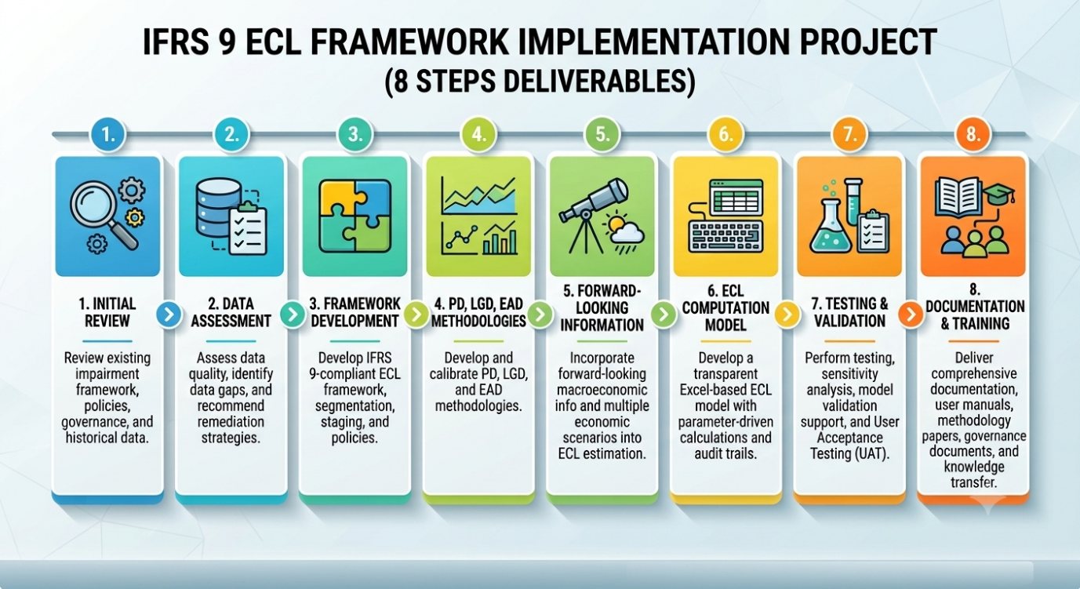

IFRS 9 Framework Development
The first stage of the engagement focuses on establishing a comprehensive IFRS 9 impairment framework tailored to Uttara Bank PLC.'s business model, portfolio characteristics, and regulatory environment. The framework will define portfolio segmentation, staging criteria, Significant Increase in Credit Risk (SICR), default definition, governance structure, accounting policies, management overlays, and impairment methodology.
The framework will incorporate quantitative indicators, qualitative assessments, and forward-looking information to ensure that impairment estimates appropriately reflect changes in credit risk throughout the life of each financial asset while remaining consistent with Bangladesh Bank guidelines and IFRS 9 requirements.

Staging and the three-stage model

Every exposure will be allocated to one of three stages. Stage 1 covers performing exposures and attracts a 12-month ECL; Stage 2 captures exposures that have experienced a significant increase in credit risk since origination and attracts a lifetime ECL; Stage 3 covers credit-impaired exposures, also at lifetime ECL, with interest recognised on the net carrying amount.
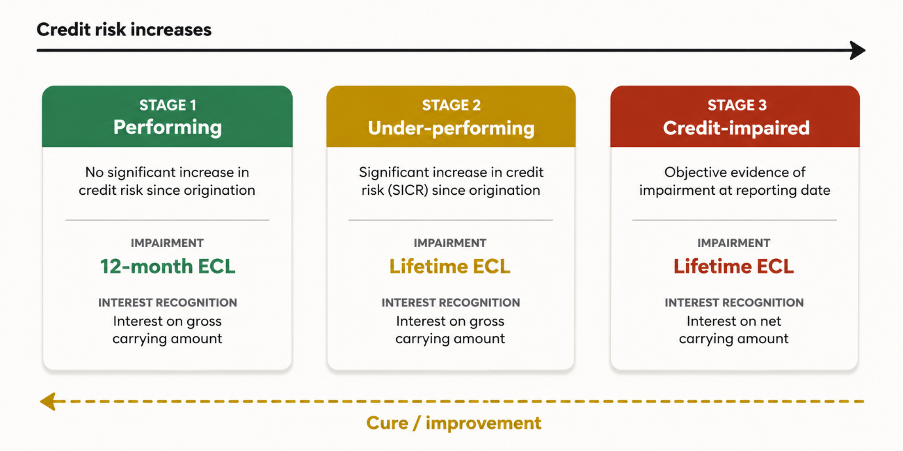
The framework will incorporate quantitative indicators, qualitative risk factors, and forward-looking information to ensure that impairment estimates appropriately reflect the underlying credit risk profile throughout the life of each financial asset.

Development of Risk Parameters

Expected Credit Loss will be measured using the internationally accepted Probability of Default (PD), Loss Given Default (LGD), and Exposure at Default (EAD) methodology. Each parameter will be developed at an appropriate portfolio level and calibrated using the Bank's historical experience, current portfolio characteristics, collateral information, recovery behaviour, and reasonable forward-looking economic expectations.

Where historical information is insufficient, statistically supportable benchmark data and proxy methodologies will be applied with appropriate management judgement and complete documentation.

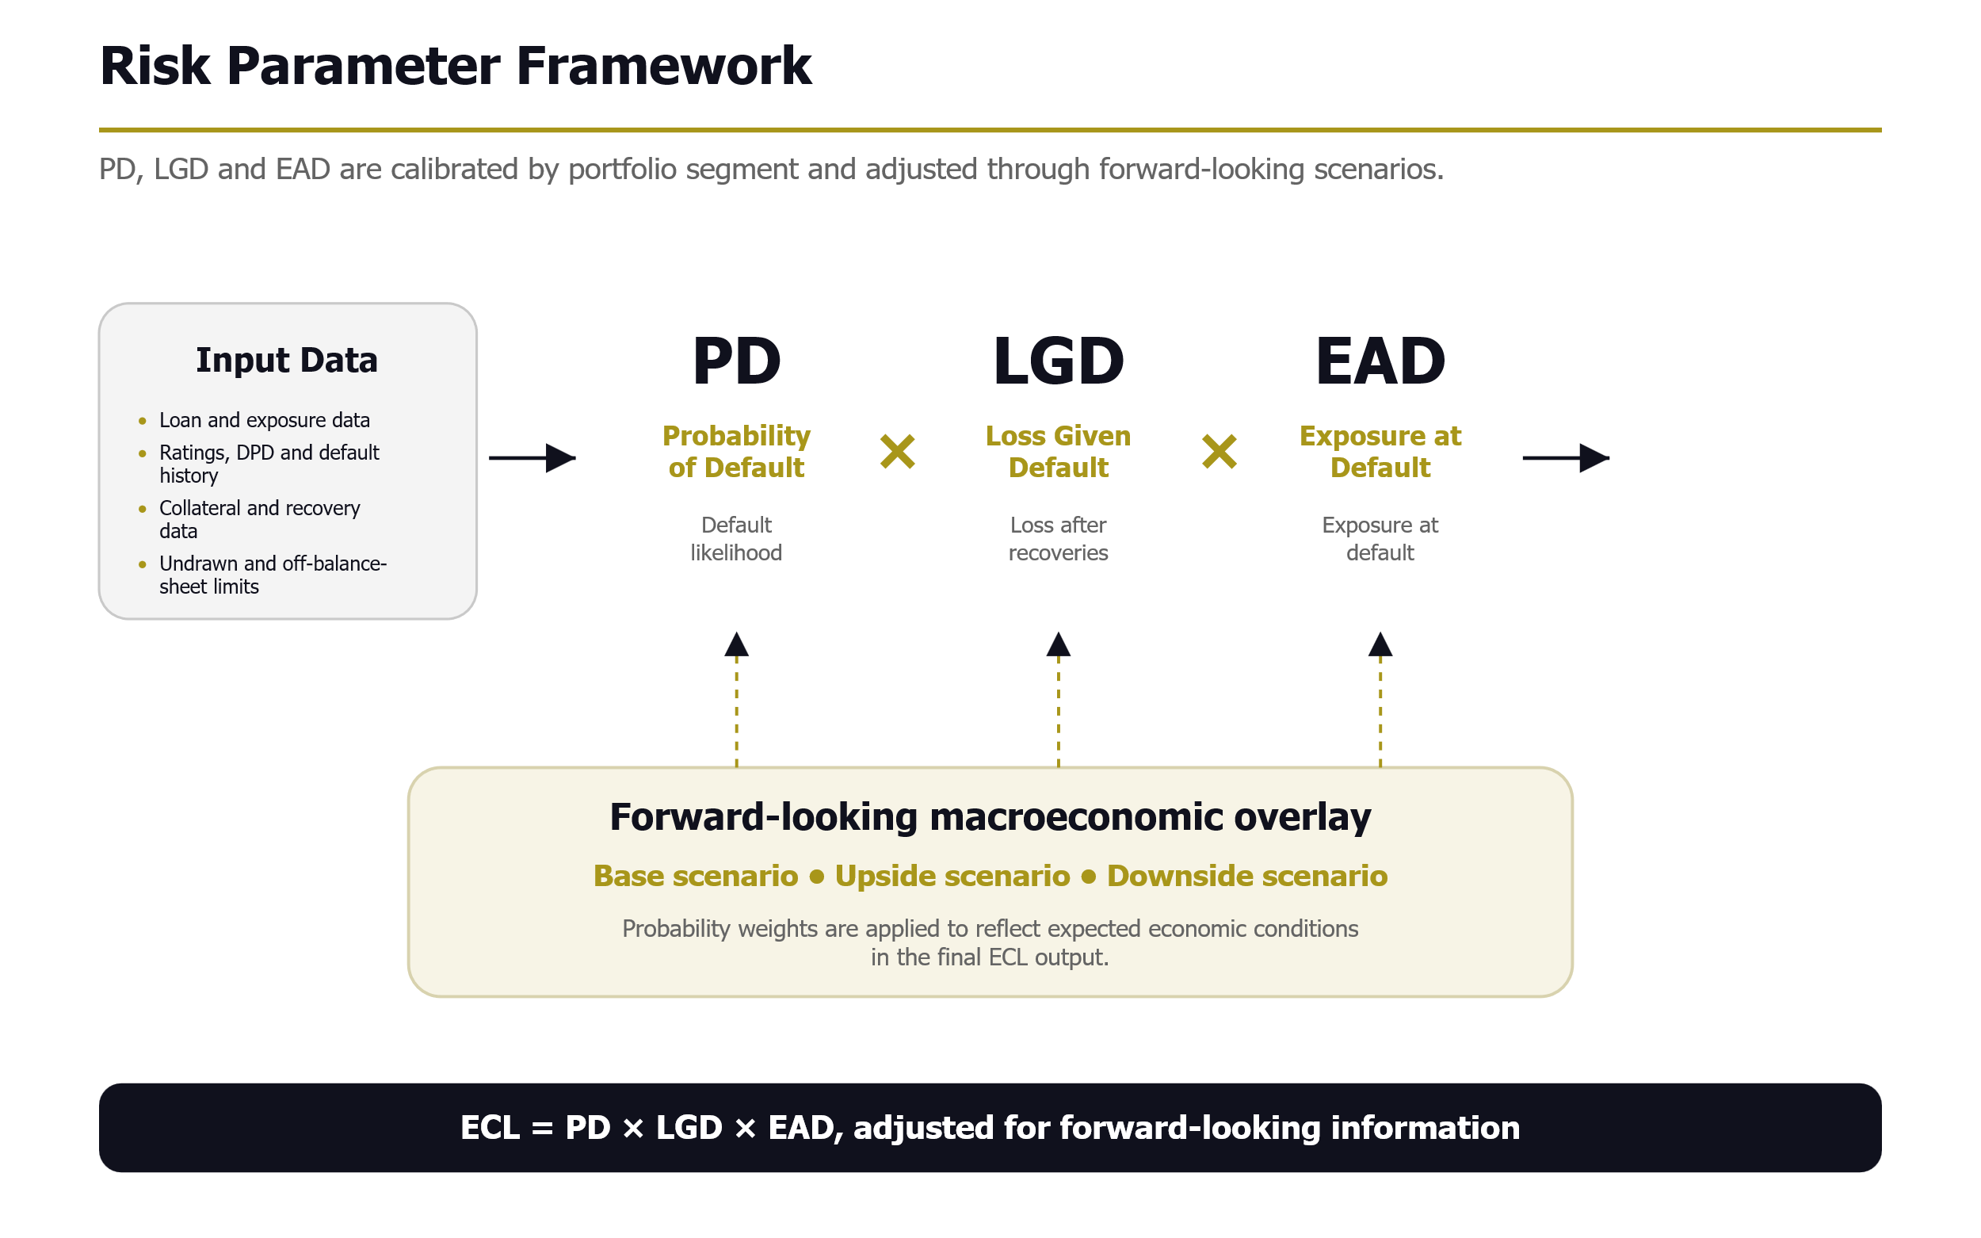
Parameter development approach

Parameter | Purpose | Basis of estimation | Proposal output
PD | Measures default likelihood over the relevant 12-month or lifetime horizon. | Internal rating grades, DPD/default history, migration patterns and portfolio behaviour; supplemented by defensible benchmarks where required. | Segment-wise PD curves and point-in-time adjustment.
LGD | Measures expected loss severity after recoveries, collateral realisation and recovery costs. | Product type, collateral class, security position, recovery timing, recovery cost and discounting impact. | Collateral-adjusted LGD by product and segment.
EAD | Measures expected outstanding exposure at the time of default. | Current balance, contractual amortisation, undrawn limits, commitments and historical drawdown behaviour. | Drawn EAD and CCF-based EAD for off-balance-sheet exposures.
Forward-looking overlay | Ensures ECL reflects expected economic conditions rather than historical experience alone. | Base, upside and downside scenarios with probability weights linked to risk parameters. | Probability-weighted ECL output.

Calibration, validation and governance

The calibrated parameters will be subject to reasonableness checks, sensitivity analysis, variance review and management sign-off. All assumptions, data sources, model judgements and limitations will be documented to support audit review, regulatory inspection and ongoing model governance.

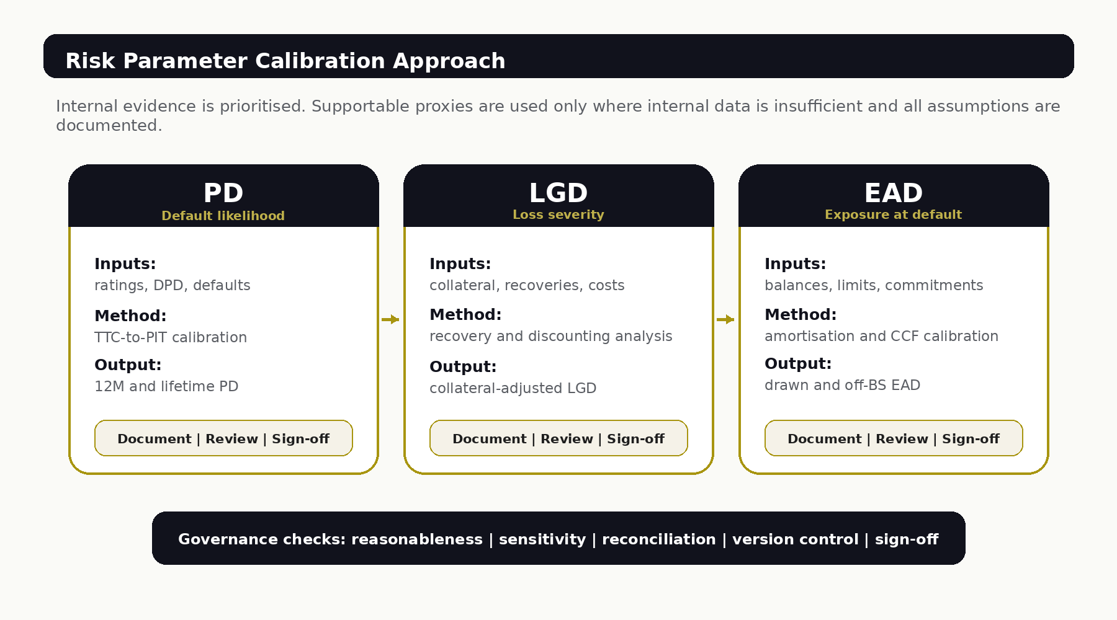

Advanced Excel Based ECL Solution
Based on the approved methodology, we will develop a robust Advanced Excel-based ECL solution capable of performing loan-level and portfolio-level impairment calculations in an efficient, transparent, and auditable manner.
The spreadsheet solution will incorporate automated calculation engines, configurable assumptions, portfolio segmentation, SICR assessment, PD/LGD/EAD calculations, forward-looking scenario analysis, management overlays, reconciliation procedures, dashboards, and standardized reporting outputs. Built-in validation controls and audit trails will enable users to trace every calculation from source data through to the final Expected Credit Loss.
The solution will be fully documented and designed to facilitate future migration to an automated system, should the Bank decide to implement a technology-based ECL platform.

Model Validation and Implementation Support

To ensure the reliability and robustness of the developed framework, comprehensive validation procedures will be performed throughout the engagement. Validation activities will include data reconciliation, reasonableness testing, sensitivity analysis, scenario testing, back-testing (where applicable), parallel run, User Acceptance Testing (UAT), and management review.
All model assumptions, methodologies, calculation logic, validation results, limitations, and governance requirements will be comprehensively documented to support regulatory inspections, internal governance, external audit, and future model enhancement.

Regulatory Reporting and IFRS 9 Disclosures
The engagement will also support the Bank in developing the documentation and reporting required for IFRS 9 implementation. This includes preparation of impairment methodology documentation, accounting policy guidance, management reporting templates, regulatory reporting support, reconciliation schedules, and illustrative financial statement disclosures consistent with IFRS 9 and Bangladesh Bank expectations.

Knowledge Transfer and Sustainability

Knowledge transfer will remain an integral part of the engagement. Throughout the assignment, our specialists will work closely with designated personnel from Finance, Risk Management, Credit, IT, and Internal Audit to ensure that the Bank develops sufficient in-house capability to independently operate, maintain, validate, and continuously enhance the ECL framework.

Training programmes, technical workshops, operational manuals, user guides, and implementation documentation will be delivered to ensure the long-term sustainability of the solution beyond project completion.

Our methodology emphasizes practicality, transparency, and long-term maintainability. Every component of the framework and Excel-based solution will be designed to remain fully understandable, auditable, and adaptable, enabling Uttara Bank PLC. to comply with evolving regulatory expectations while establishing a sustainable impairment framework for future years.

Proposed Deliverables

The following deliverables will be provided throughout the engagement to support the successful implementation of an IFRS 9-compliant Expected Credit Loss (ECL) framework and Advanced Excel-based ECL solution.
Sl. No. | Deliverable | Description
1 | Project Initiation Report | Project charter, implementation roadmap, governance structure, detailed work plan, communication protocol, and Information Request List (IRL).
2 | Data Assessment Report | Assessment of historical data, data quality review, gap analysis, data mapping, and recommendations for addressing identified deficiencies.
3 | IFRS 9 ECL Framework | Comprehensive framework covering portfolio segmentation, staging methodology, SICR assessment, default definition, governance, accounting policies, and impairment methodology.
4 | Risk Parameter Methodologies | Documented methodologies for PD, LGD, EAD, forward-looking macroeconomic scenarios, management overlays, and parameter calibration.
5 | Advanced Excel-Based ECL Solution | Fully functional Excel-based ECL model incorporating automated calculations, configurable assumptions, dashboards, reporting templates, audit trails, and user-friendly interfaces.
6 | Validation and Testing Report | Results of data reconciliation, reasonableness testing, sensitivity analysis, scenario testing, User Acceptance Testing (UAT), and parallel run validation, together with recommendations for improvement.
7 | Reporting and Disclosure Templates | Standardized management reports, regulatory reporting templates, reconciliation schedules, and illustrative IFRS 9 financial statement disclosures.
8 | Technical Documentation | Model documentation, calculation methodology, user manuals, operating procedures, technical specifications, and governance documentation.
9 | Training and Knowledge Transfer | Training materials, workshop presentations, operational guidance, and hands-on knowledge transfer sessions for relevant Bank personnel.
10 | Final Implementation Report | Summary of implementation activities, key assumptions, outstanding observations, recommendations, and post-implementation support plan.

Our Assumptions

Successful implementation of an IFRS 9 Expected Credit Loss (ECL) framework requires close collaboration between the Consultant and Uttara Bank PLC. Throughout the engagement, project risks will be continuously monitored, assessed, and addressed through proactive planning and regular stakeholder communication. The key project risks and proposed mitigation measures are summarized below:

- Uttara Bank PLC. will provide timely access to all relevant historical and current portfolio data, customer information, collateral details, recovery records, financial information, and other documentation required for the development and implementation of the IFRS 9 Expected Credit Loss (ECL) framework.
- The Bank will nominate a dedicated Project Coordinator and designate appropriate representatives from Finance, Credit Risk Management, Information Technology, Internal Audit, Treasury, and other relevant departments to facilitate project coordination, decision-making, and timely review of deliverables.
- Required access to the Bank's Core Banking System (CBS), Management Information System (MIS), supporting applications, and relevant reports will be provided as necessary to perform data assessment, model development, validation, and implementation activities.
- Historical data provided by the Bank will be complete, accurate, and reasonably reliable for developing the ECL methodology. Where data limitations exist, reasonable and supportable proxy methodologies, benchmark information, and expert judgement may be applied with the Bank's agreement and appropriate documentation.
- Management will review project deliverables and provide comments, clarifications, approvals, and required decisions within mutually agreed timelines to avoid delays in project execution.
- Relevant business users and subject matter experts will be available for workshops, interviews, data validation sessions, methodology discussions, User Acceptance Testing (UAT), training programmes, and knowledge transfer activities.
- The Advanced Excel-based ECL solution will be developed based on the approved methodology, agreed business rules, and information made available during the engagement. Any subsequent changes to business requirements, regulatory expectations, or accounting policies after approval may require corresponding revisions to the solution, project timeline, or commercial terms.
- The Excel-based ECL solution is intended to support the Bank's IFRS 9 impairment assessment in a transparent and auditable manner. Future migration to a fully automated or system-based implementation, if desired by the Bank, will constitute a separate engagement unless otherwise agreed.
- Development of Core Banking System modifications, APIs, database applications, software development, third-party integrations, or procurement of software licences is outside the scope of this engagement unless specifically included through a mutually agreed change request.
- Independent model validation by an external validator, regulatory approval by Bangladesh Bank, and external audit certification of the developed framework are outside the Consultant's responsibility. However, all necessary documentation and implementation support required for such reviews will be provided.
- The project schedule assumes timely availability of data, system access, management decisions, required resources, and feedback from the Bank. Delays in these areas may require corresponding adjustments to the implementation timeline.
- Any significant changes to IFRS, Bangladesh Bank regulations, or other applicable regulatory requirements during the engagement that materially affect the agreed scope of work may require revisions to the methodology, deliverables, implementation schedule, and project effort.

Service Level Agreement (SLA) and Post-Implementation Support

ACNABIN is committed to supporting Uttara Bank PLC. throughout the implementation and operationalization of the IFRS 9 Expected Credit Loss (ECL) framework. Our post-implementation support is designed to facilitate the successful adoption of the developed methodology and Advanced Excel-based ECL solution while enabling the Bank to independently operate, maintain, and continuously enhance the framework.

The objective of the support services is to ensure the reliability, sustainability, and regulatory compliance of the implemented ECL framework through timely technical assistance, knowledge transfer, and advisory support.

Scope of Post-Implementation Support

Our post-implementation support will include, but not be limited to, the following:

- Clarification of the IFRS 9 impairment methodology, assumptions, modelling techniques, and calculation logic.
- Assistance in the operation and periodic execution of the Advanced Excel-based ECL solution.
- Resolution of calculation errors, formula issues, logical inconsistencies, and implementation-related observations identified during the agreed support period.
- Guidance on data preparation, validation procedures, reconciliation, and interpretation of model outputs.
- Support during User Acceptance Testing (UAT), pilot implementation, parallel run, and initial operational deployment.
- Advisory support for model calibration, management overlays, scenario analysis, and parameter refinement where required.
- Assistance in preparing regulatory reporting, management reports, and IFRS 9 impairment disclosures arising from the implemented framework.
- Clarification of technical documentation, user manuals, governance documents, and operational procedures developed under the engagement.
- Support in addressing implementation observations raised by Internal Audit, External Auditors, or Bangladesh Bank relating to the developed framework and deliverables.
- Knowledge transfer and technical guidance to designated Bank personnel to strengthen in-house capability for ongoing operation and maintenance of the framework.

Service Levels

Severity Level | Description | Target Response Time | Target Resolution Time*
Critical | Issue preventing execution of the ECL model or generation of impairment results. | Within 1 Business Day | Within 3 Business Days
High | Significant issue affecting calculation accuracy, reporting, or implementation activities where a temporary workaround is available. | Within 1 Business Day | Within 5 Business Days
Medium | Functional issue, configuration clarification, documentation query, or support relating to data validation, reporting, or reconciliation. | Within 2 Business Days | Within 7 Business Days
Low | General advisory requests, enhancement recommendations, user guidance, or interpretation of methodology. | Within 3 Business Days | Mutually Agreed Timeline
*Resolution timelines are subject to timely availability of required information, system access, and cooperation from Uttara Bank PLC.

Support Channels
Support services may be provided through one or more of the following channels, depending on the nature of the request:
- Email correspondence
- Virtual meetings (Microsoft Teams/Zoom or equivalent)
- Telephone discussions
- Onsite workshops or technical sessions, where mutually agreed
- Periodic project review meetings during the agreed support period

Knowledge Transfer
Comprehensive knowledge transfer will be conducted throughout the engagement to ensure that designated personnel of Uttara Bank PLC. can independently operate and maintain the developed framework. Training programmes will include:

- Overview of IFRS 9 impairment requirements and governance.
- Operation of the Advanced Excel-based ECL solution.
- Data preparation, validation, and reconciliation procedures.
- Execution of periodic Expected Credit Loss calculations.
- Interpretation of model outputs, management overlays, and scenario analysis.
- Maintenance of model assumptions, parameters, and documentation.
- Preparation of regulatory reports and IFRS 9 financial statement disclosures.

Upon completion of the assignment, all project-specific deliverables including the Advanced Excel-based ECL solution, templates, methodology documents, user manuals, training materials, and operational documentation will be handed over to Uttara Bank PLC.

Intellectual Property
Upon completion of the engagement and settlement of all contractual obligations, Uttara Bank PLC. shall retain ownership of all deliverables specifically developed under this assignment, including the Advanced Excel-based ECL solution, templates, reports, documentation, user manuals, and training materials. ACNABIN and its consortium partners shall retain ownership of their proprietary methodologies, implementation approaches, generic tools, working papers, intellectual capital, and know-how developed independently of this engagement. Nothing in this engagement shall restrict ACNABIN from applying its professional knowledge, experience, or methodologies in future assignments, provided that no confidential information relating to Uttara Bank PLC. is disclosed.

Confidentiality & Conflict of Interest Declaration

We declare that all information provided by Uttara Bank PLC will be treated as strictly confidential and used solely for the purpose of this engagement. Furthermore, we confirm that there is no conflict of interest in undertaking this advisory and implementation role.

The Proposed Project Team Composition

We propose forming an assurance team having sufficient expertise and knowledge. The proposed assurance team will conduct the assignment as required by the reporting deadline. Our proposed team will be formed as follows:

Sl.# | Name | Organization | Designation | Qualifications | Experience
Governance & Review
01 | Muhammad Aminul Hoque, FCA | ACNABIN | Partner | BBA (DU), MBA (DU), FCA | 20+ Years
02 | Md. Aktaruzzaman Sarker | CipherShield | Chief Information Officer | CISA, MSc in Cyber Security, ISO 27001 Lead Auditor | 28+ Years
03 | Mahender Lal, ACA | SolveOrbit | IFRS Specialist | ACA | 7+ Years
IFRS 9-ECL System Specialist
04 | Aahad Aazar | SolveOrbit | IT Specialist | Software Engineer | 8+ Years
05 | Sabahat Siddiqui, CBA | SolveOrbit | IFRS Specialist | CBA | 7+ Years
06 | Muhammad Asaduzzaman | CipherShield | Cyber Security Manager | CISA, Master of Engineering in Information System Security | 18+ Years
07 | Fouzan A. Shaikh | CipherShield | Chief Operating Officer | CISA, Bachelor of Engineer - Electronics & Telecommunications | 15+ Years
Banking Sector Audit/Review Specialist
08 | Abdullah Al Mamun, FCA | ACNABIN | Director | BBA (DU), MBA (DU), FCA | 20+ Years
09 | Mahmudur Rahman, FCA | ACNABIN | Director | BBA (DU), MBA(DU), FCA, ACMA(UK), CGMA, ACFE | 16+ Years
10 | Nusrat Maria, FCCA, ACA (ICAEW) | ACNABIN | Deputy Director | B.Sc. (UK), FCCA, ACA (ICAEW) | 10+ Years
11 | Yeasin Arafat Razon | ACNABIN | Senior Student | BBA, MBA in Accounting (DU) | 2+ Years
ECL Modeling & Economists
12 | Md Shamshad Alam, ACA | ACNABIN | Manager | BBA in Finance (DU), ACA | 4+ Years
13 | Md Real Miah, ACA | ACNABIN | Manager | BBA in Finance (DU), ACA, Certified in Econometrics & Data Science | 4+ Years
14 | Md Nazir Hossain ACA | ACNABIN | Manager | BBA in Finance (DU), ACA | 4+ Years
Please see Annexure C for detailed CV.

Proposed Timeline

The engagement is expected to be completed over a period of approximately 20 weeks, subject to timely availability of data, stakeholder participation, and review of deliverables.

Activities | Week
Activities | 1 | 2 | 3 | 4 | 5 | 6 | 7 | 8 | 9 | 10 | 11 | 12 | 13 | 14 | 15 | 16 | 17 | 18 | 19 | 20
Project Initiation & Kick-off | ■ | ■
Data Collection & Gap Assessment | ■ | ■ | ■ | ■
Data Validation & Mapping |  |  | ■ | ■ | ■
IFRS 9 Framework Development |  |  | ■ | ■ | ■ | ■
Portfolio Segmentation & SICR Methodology |  |  |  | ■ | ■ | ■ | ■
PD, LGD & EAD Methodology Development |  |  |  |  | ■ | ■ | ■ | ■ | ■
Forward-looking Scenarios & Management Overlay |  |  |  |  |  | ■ | ■ | ■ | ■
Advanced Excel-Based ECL Solution Development |  |  |  |  |  | ■ | ■ | ■ | ■ | ■ | ■ | ■
Model Validation & Sensitivity Analysis |  |  |  |  |  |  |  |  | ■ | ■ | ■ | ■
User Acceptance Testing (UAT) |  |  |  |  |  |  |  |  |  |  | ■ | ■ | ■
Parallel Run & Refinement |  |  |  |  |  |  |  |  |  |  |  | ■ | ■ | ■ | ■
Regulatory Reporting & IFRS 9 Disclosures |  |  |  |  |  |  |  |  |  |  |  |  | ■ | ■ | ■
Documentation & User Manuals |  |  |  |  |  |  |  |  |  |  |  |  | ■ | ■ | ■ | ■
Training & Knowledge Transfer |  |  |  |  |  |  |  |  |  |  |  |  |  |  | ■ | ■ | ■
Final Deliverables & Project Closure |  |  |  |  |  |  |  |  |  |  |  |  |  |  |  |  | ■ | ■ | ■ | ■
■ = Planned Activity

Note: 1. The above timeline is indicative and may be adjusted based on timely availability of required data, system access, stakeholder feedback, management approvals and progress of related implementation activities of Uttara Bank PLC. and instruction given by Bangladesh Bank.
2. Post-implementation support will be provided in accordance with the agreed Service Level Agreement (SLA) following acceptance of the final deliverables.

